**CH 246: ORGANIC CHEMISTRY II LABORATORY (Spring 2021)**

**Title:** Carbonyl Reactions

1. **Purpose: (1 point)**

**The purpose of this experiment is to identify three unknown compounds by creating their derivatives with carbonyl reactions and running qualitative tests on the derivatives.**

1. **Drawing of structure of the main compound or balanced chemical equation if synthesis is performed: (1 point)**

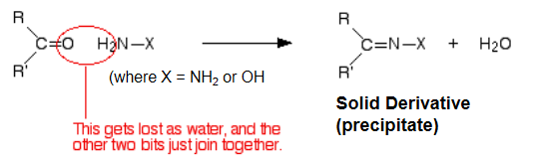

Semicarbazide Reaction:

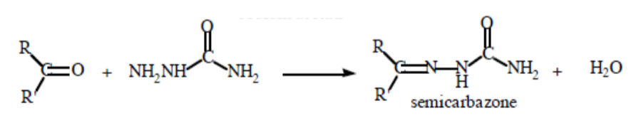

**3. Reagents and the major product (up to 5 points)**

|  |  |  |  |  |  |  |
| --- | --- | --- | --- | --- | --- | --- |
| **Name** | **M.W.**  (0.5 pts) | **Density**  (0.5 pts) | **Amount (grams/mL)**  (0.5 pts) | **Moles**  (0.5 pts) | **Hazards/Precautions**  **(MSDS data) and melting point or boiling point** (2 pts) | **Role of the reagent** (1 pts)* |
| 2,4-dinitrophenylhydrazine | 198.14 | 1.7 g/cm3 | 0.8 grams | 0.00403 | Flammable solid. Causes eye irritation. May cause skin and respiratory tract irritation.  MP: 198-201°C | Reactant |
| 3,5-dinitrobenzoyl chloride | 230.56 | 1.7 g/cm3 | -- | -- | Causes severe skin burns and eye damage.  MP: 67-70°C  BP: 196°C | Reactant |
| Semicarbazide hydrochloride | 111.53 | 1.286 g/cm3 | 0.25 grams | 0.0224 | May cause eye and skin irritation. May cause respiratory and digestive tract irritation.  MP: 176°C | Reactant |
| Methanol | 32.04 | 0.792 g/cm3 | 45 mL | 1.112 | May be fatal or cause blindness if swallowed. Flammable. Causes eye, skin, and respiratory tract irritation.  MP: -98°C  BP: 65°C | Solvent |
| Sulfuric Acid | 98.07 | 1.84 g/cm3 | 1.5 mL | 0.0281 | Causes eye and skin burns. May be fatal if mist inhaled. Corrosive.  MP: 10°C  BP: 290-338°C | Reactant |
| Ethyl acetate | 88.11 | 0.9 g/cm3 | -- | -- | Flammable liquid and vapor. Causes eye irritation. May cause respiratory tract irritation.  MP: -83°C  BP: 77°C | Solvent |
| Sodium acetate | 82.03 | 1.53 g/cm3 | 0.4 grams | 0.00487 | May cause eye, skin, and respiratory tract irritation.  MP: 324°C | Reactant |

**\*** Mention role as either reactant, solvent, catalyst or product

**4. Calculations: (1 point)**

Show each calculation for moles of reagents and for theoretical and actual yield. Fill in the box with the limiting reagent and theoretical yield:

N/A

The limiting reagent is

The theoretical yield is

**5. Procedure (up to 2 points)**

|  |  |
| --- | --- |
| **Procedure** | **Observations and Lab Data** |
| A summary of the procedure done with bullet points) | Color changes, exothermic or endothermic reactions, gas generation, etc.; tare weights for flasks, etc. |
| DNP Test:   * Weigh 0.8 grams of 2,4-dinitrophenylhydrazine into a 125 mL Erlenmeyer flask and add 4 mL of water and dropwise 4 mL conc. sulfuric acid. * Cool solution if needed and then add 40 mL of methanol. * Divide solution into three portions. * Dissolve 0.3 grams each of the three unknowns in 5 mL of methanol in three separate small flasks. (Make sure to label flasks) * Add each of the unknown solutions dropwise into each of the three portions of DNP stock solution. (Make sure they are labeled) * Record observations. If no reaction occurs, warm reaction mixture gently on a steam bath for 5 min and allow to cool. * If precipitate is observed, cool the mixture in ice bath for a few minutes and collect product by vacuum filtration. Wash crystals with small amount of cold methanol and dry thoroughly. * Record a melting point determination of all dry precipitates. Compare their melting points with the table to determine the substance’s identity. * If melting point determination is inconclusive, recrystallize precipitate in methanol-water or ethanol-ethyl acetate. * For carbonyl compounds, prepare a second derivative with semicarbazone. * Take 0.25 g semicarbazide HCl in an Erlenmeyer flask. * Make a solution of 0.4 g of sodium acetate in 3 mL of H2O. * Add sodium acetate solution to semicarbazide solution. * Add 0.25 g of precipitate to mixture. * Swirl/stir with a glass rod. Crystals should appear. * Vacuum filter crystals, and wash with cold water. * Dry crystals and take melting point of this second derivative. * If the melting points of the compounds do not match, recrystallize the compounds and try again. * Make a tentative identification based on the melting points of the derivatives. * Confirm identities using IR and NMR spectra. |  |

**6.** Results; include actual yield in grams and % yield.

**Results (need to get signed by instructor or TA):**